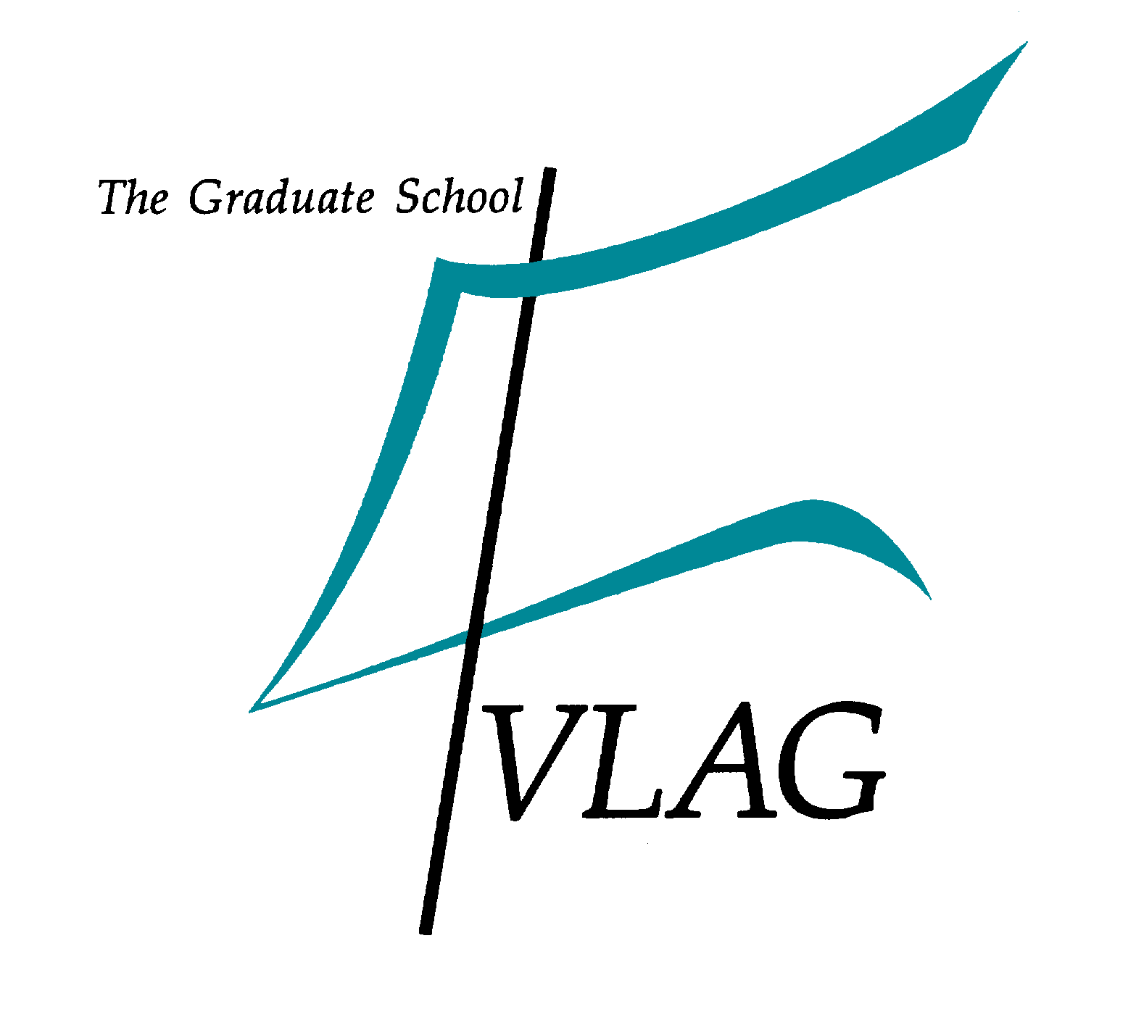

14th VLAG Open Round

Call for research proposals for PhD and Postdoc projects

Introduction

Within Wageningen University an annual budget of 2.6 M€ is divided among the six Graduate Schools to support strategic choices. Being the largest Graduate School, VLAG receives about 25% of this budget that enables us to support interdisciplinary collaborative research projects through so-called VLAG Open Rounds. Since 2001 a total of 13 Open Rounds were organised (including one transdisciplinary ß–γ round) which resulted in funding of 82 PhD projects and 4 postdoctoral researchers.

VLAG Graduate School announces a new Open Round for research proposals funded by Wageningen University and possibly research institutes participating in VLAG. Within the current round, we intend to support 4 projects, which implies that VLAG provides the salary costs for the appointment of a PhD or a postdoctoral researcher. The additional 35% for the so-called ‘integral costs’ within Wageningen University is also provided. The applicants jointly guarantee the financing of the remaining research costs.

Focus of the current call: Incentives to strengthen the VLAG Community & VLAG Research Themes

In 2019 new research themes were defined within VLAG that form the basis for the international peer review. To provide incentives to exploit potential synergies and complementarity within and across VLAG Research Themes we have decided upon a specific implementation for our 14th Open Round that is inspired by the feedback from the Mid-term review (2018) and the vision of the VLAG scientific director.

We aim to:
- Provide incentives for collaboration within and across VLAG Research Themes
- Invite recently appointed Tenure Track candidates to submit proposals, and lead the initiatives
- Safeguard ‘blue skies’ research

Who is Eligible?
Tenure Track candidates from VLAG chair groups that entered into the Tenure Track after January 1st, 2018 (Annex I: List of eligible VLAG associated Tenure Track candidates).

How to Apply?
- Submit a short bio-sketch (max 250 words) and description of your research field/line
(max 750 words) before 15 September 2020 including
  - recent developments and future directions
  - potential for collaborations, ideally focussing on the combinations mentioned in the application requirements section
- Join the VLAG Matching Event (30 September 2020, link to register) within which you need to:
- Present an engaging 7 minutes pitch about your research field/line
- Network with other eligible Tenure Track candidates and form partnerships
(see Application Requirements)
If your physical presence is not possible, please prepare a recorded pitch that will be shared with the other participants.
- Fill out the new VLAG Open Round research proposal template with at least one other eligible Tenure Track candidate. Each candidate may be involved in 1 research proposal. The template for the research proposal can be found at the VLAG website
(LINK: https://www.vlaggraduateschool.nl/en/research-1/VLAG-Calls.htm)
- Submit your research proposal before the deadline

Application Requirements
Within this round, we will support 4 PhD or Postdoc projects based on the following distribution over the VLAG Research Themes:
- Chemistry for Life Sciences and Bio-based Economy will get 1 PhD or Postdoc project for a collaboration of two eligible TT candidates from within the theme
- Modelling & Design of Biological Systems will get 1 PhD or Postdoc project for a collaboration of two eligible TT candidates from within the theme
- Food Science and Technology & Human Nutrition and Health will get 2 PhD or Postdoc projects for cross-themes collaboration between an eligible Food TT candidate and an eligible Nutrition TT candidate.

The research projects should:
- Involve at least two chair groups participating in VLAG as stipulated above.
- Be collaborations to which both groups contribute equally from a scientific point of view and should not be based solely on methodological/technical support.
- Be ‘blue skies’ research ideas – that are not part or a continuation of an existing research project/programme. We are particularly looking for high-risk innovative, explorative, and original proposals that may be difficult to get funded elsewhere.

We hope that bringing our newest generation of researchers together will spark future collaborations and even new research lines, not limited to the projects funded by VLAG.

The composition of the research team cannot be changed upon granting the project.
The PhD / Postdoc projects granted within this Open Round should start in 2021.

Timeline of application and selection process 2020/2021:
- The VLAG Matching event will take place on 30th September 2020 (10:00 – 14:00 h)
- Closing date for submitting the research proposal is 16th November 2020
- Eligibility & quality check in November 2020
- Selection of the proposals by random allocation (i.e. lottery) early December 2020

Involvement of Research Institutes

The research institutes (see annex II) can participate by co-submitting research proposals together with a ‘Tenure Track team’ described above and are expected to co-finance 25% of the PhD/Postdoc salary and part of the research costs.

If you have comments and/or questions, please contact Vesna Prsic (vesna.prsic@wur.nl) for advice.

Wageningen, 12 August 2020

Annex I - List of eligible VLAG associated Tenure Track candidates

# | NAME | CHAIR GROUP | Start in TT
VLAG Research Theme I - Chemistry for Life Sciences and Bio-based Economy
1 | Terenzi, Camilla | Biophysics | 1-7-2018
2 | Salentijn, Gert | Organic Chemistry | 9-7-2018
3 | Swarts, Daan | Biochemistry | 1-1-2019
4 | Deshpande, Siddharth | Physical Chemistry and Soft Matter | 1-11-2019
5 | Li, Guanna | Biobased Chemistry and Technology & ORC | 1-2-2020
6 | Krug, Julia | BioNano Technology | 1-4-2020
7 | Miloserdov, Fedor | Organic Chemistry | 1-8--2020
8 | Kiewidt, Lars | Biobased Chemistry & Technology | 18-9-2020
VLAG Research Theme II - Food Science & Technology
9 | Hennebelle, Marie | Food Chemistry | 1-1-2018
10 | Bijl, Etske | Food Quality and Design | 2-5-2019
11 | Keppler, Julia | Food Process Engineering | 1-6-2019
12 | Ruiter, Jolet de | Food Process Engineering | 1-6-2019
13 | Zhang, Lu | Food Process Engineering | 1-4-2020
14 | Araya Cloutier, Carla | Food Chemistry | 1-6-2020
15 | Bruijn, Wouter de | Food Chemistry | 1-6-2020
16 | Hoppenbrouwers, Tamara | Food Quality and Design & WFBR | 1-7-2020
17 | Landman, Jasper | Food Physics | 1-8-2020
VLAG Research Theme III - Human Nutrition & Health
18 | Verhoef, Hans | Global Nutrition | 1-7-2019
19 | Winkels, Renate | Nutrition and Disease | 1-8-2019
20 | Brouwer-Brolsma, Elske | Global Nutrition | 1-1-2020
21 | Timmers, Silvie | Human and Animal Physiology | 1-1-2020
22 | Talsma, Elise | Global Nutrition | 1-9-2020
23 | Gonzales, Gerard Bryan | Nutrition, Metabolism and Genomics | 1-10-2020
VLAG Research Theme IV - Modelling & Design of Biological Systems
24 | Bouwmeester, Hans | Toxicology | 1-1-2018
25 | D'Adamo, Sarah | Bio Process Engineering | 8-1-2018
26 | Saccenti, Edoardo | Systems and Synthetic Biology | 1-7-2019
27 | Brugman, Sylvia | Host Microbe Interactomics | 1-4-2020
28 | Claassens, Nico | Microbiology | 1-5-2020
29 | Bisschops, Mark | Bio Process Engineering | 1-10-2020
More information about researchers: https://research.wur.nl/

Annex II – Researchers at institutes actively participating in VLAG Graduate School

Wageningen Food & Biobased Research
Carmen Boeriu
Marieke Bruins
Esmee Doets
Daan Van Es
Coen Govers
Jacco Van Haveren
Ana Lopez Contreras
Marcel Meinders
Jurriaan Mes
Prof. Ruud Van Der Sman
Prof. Harry Wichers
Rene De Wijk
Nicole De Wit
Gertrude Zeinstra
Wageningen Food Safety Research
Dr Toine Bovee
Prof. Ine Van Der Fels-Klerx
Dr Arjen Gerssen
Dr Leen van Ginkel
Dr Stefan van Leeuwen
Dr Jochem Louisse
Prof. Michel Nielen (ORC)
Dr Annemieke Pustjens
Prof. Saskia van Ruth (FQD)
Dr Meike van der Zande
NIZO food research
Dr Alwine Kardinaal
Dr Hans Tromp
Dr Marjon Wells-Bennik
Dr Nel Zoon
RIVM - National Institute of Public Health and the Environment
Prof. Hendriek Boshuizen
Dr Wilma Jacobs-Reitsma
Dr Marga Ocké
Prof. Aldert Piersma
Dr Reinskje Talhout
Dr Liesbeth Temme

